Tweet 1
If you're unable to apply for Pregnancy and Baby Payment due to COVID-19 @SocSecScot are now accepting applications up until your baby turns one. If you're a kinship carer this has been extended to one year and six months old

Apply online at mygov.scot/best-start-grant-best-start-foods/

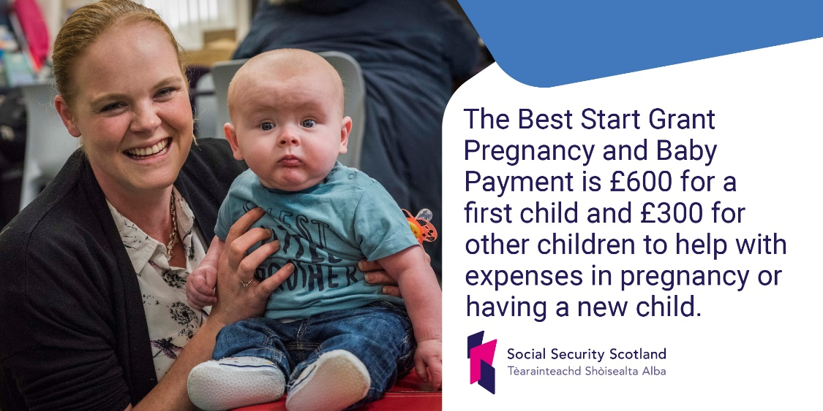

Tweet 2
Parents or carers under the age of 18 are automatically entitled to Best Start Grant Pregnancy and Baby Payment. People could still be eligible after their 18th birthday if Covid-19 meant that they couldn’t get their application in on time.

Apply for Best Start Grant online at mygov.scot/best-start-grant-best-start-foods/

Tweet 3
If you were unable to apply for Best Start Grant Early Learning Payment due to COVID-19 @scotgov are extending eligibility up until your child’s 4th Birthday.

Apply for Best Start Grant online at mygov.scot/best-start-grant-best-start-foods/

Tweet 4
Parents or carers under the age of 18 are automatically entitled to Best Start Grant School Age Payment. People could still be eligible after their 18th birthday if Covid-19 meant that they couldn’t get their application in on time.

Apply for Best Start Grant online at mygov.scot/best-start-grant-best-start-foods/

Tweet 5

.@SocSecScot are now accepting applications from young carers who were eligible for Young Carer Grant but unable to apply for it before turning 19 due to COVID-19.

Find out more about the grant and apply here: mygov.scot/young-carer-grant

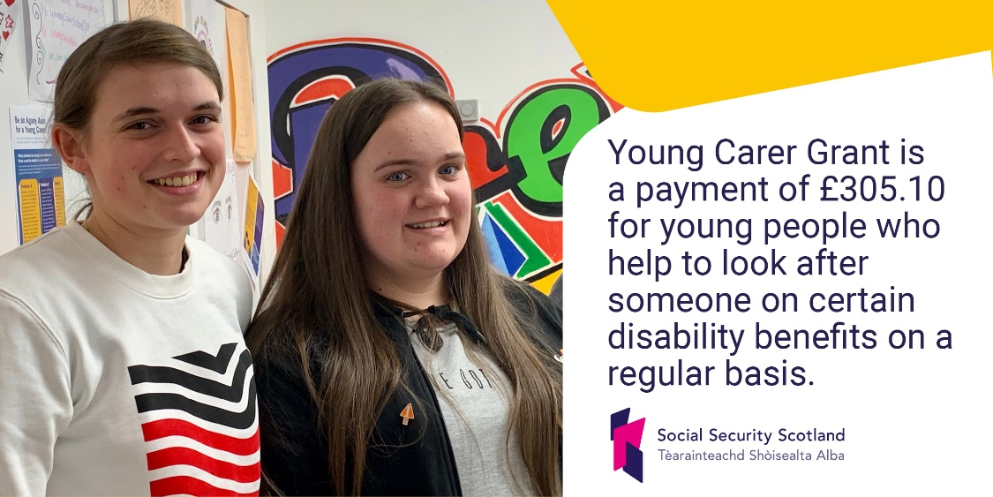

Tweet 6
Applications for Funeral Support Payment can be made up to six months after the funeral has taken place. But if you miss this deadline due to COVID-19 @SocSecScot will still consider applications.

For more information and to apply visit mygov.scot/funeral-support-payment/

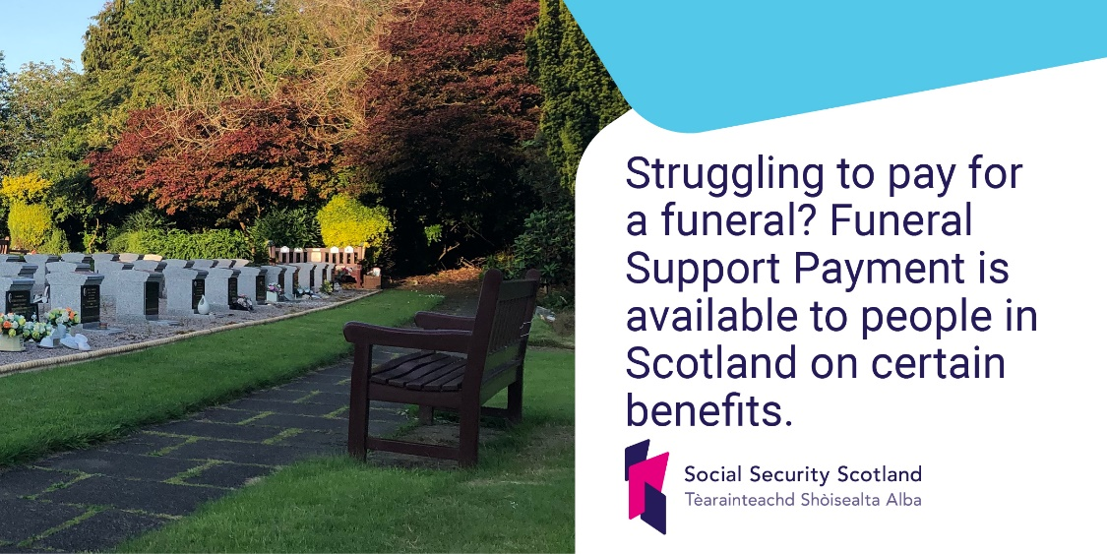

Tweet 7

To ensure people can still get support from @SocSecScot if Covid-19 stops them getting an application in on time, @ScotParl approved emergency legislation extending eligibility timescales.

Read about the changes here – socialsecurity.gov.scot/news/making-sure-people-impacted-by-covid-19-get-our-support

