Funeral Support Payment statistics to 31 March 2025

Key findings

In the 2024/25 financial year:

- 8,535 applications were received.
- 8,465 applications were processed, of which 72% were authorised, 17% were denied, and 10% were withdrawn.
- the average (median) processing time was 12 working days.
- £12.2 million had been paid out to clients and funeral directors.

Frequency of publications
The next publication, covering up to the 30 June 2025, will be released in September 2025. Under the Code of Practice for Official Statistics we publish a timetable of statistical releases for the twelve months ahead.

Contents
Key findings 1
Introduction 3
Main findings 4
Background notes 9
Eligibility 9
Payment amount 10
Application and decision making process 13
Re-determinations and appeals 14
About the data 14
How the data is collected 15
Quality assurance 15
Revisions 16
Data quality 16
Future developments 20
Related statistics and publications 21
Correspondence and enquiries 21
Complaints and suggestions 21

Introduction

Social Security Scotland began taking applications for Funeral Support Payment on 16 September 2019. This publication provides information on applications and payments for Funeral Support Payment from this date to 31 March 2025.
The Background section has further details about what Funeral Support Payment is, who can receive it and how much they can be paid.
All tables and charts for this publication can be found at Social Security Scotland statistics website.
We have made some changes to the re-determination reporting in Table 10 as part of the previously communicated continuous improvement exercise. Further details of these changes are described in the “Re-determinations and appeals data and methodology review” section.
If you have any comments or suggestions that you would like to provide us around these changes or other developments, please email MI@socialsecurity.gov.scot.
These statistics are being published as official statistics in development. Official statistics in development may be new or existing statistics, and will be tested with users, in line with the standards of trustworthiness, quality and value in the Code of Practice for Statistics. The UK Statistics Authority has not yet assessed these statistics. They have not been designated as Accredited Official Statistics.
The data and methods underpinning Social Security Scotland statistics are routinely reviewed in line with the Code of Practice for Statistics. Ongoing data quality issues and revisions made to the statistics are detailed in our Data and Methodology Changes document. More information on how we create and use statistics can be found on our About Statistics page.

Main findings

48,265 applications for Funeral Support Payment have been received up to 31 March 2025.

8,535 of those applications were received in the 2024/25 financial year.

Figure 1: Applications have generally declined over 2024 with a slight rise at the beginning of 2025. Usually, January is the month that receives the most applications each year.

Applications received by month, from January 2024 to March 2025.
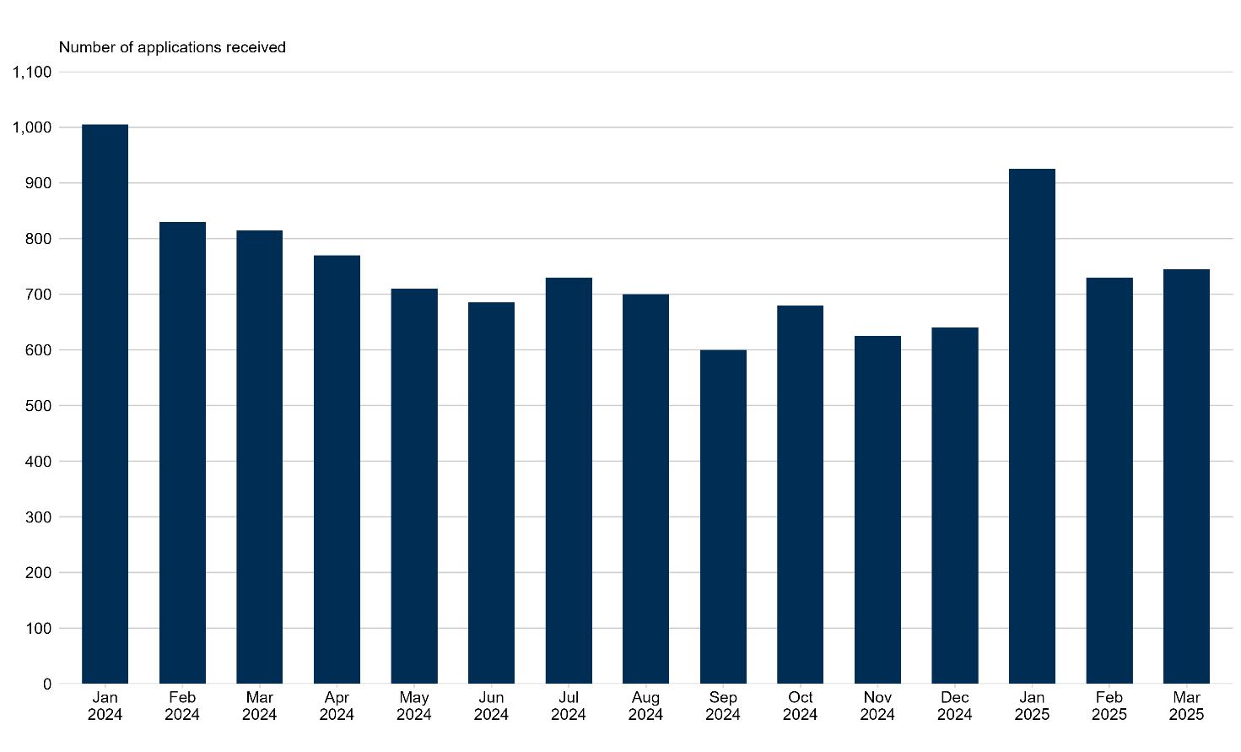

73% of processed applications have been authorised.

From 16 September 2019 to 31 March 2025, there were 47,535 applications processed. Of these, 73% were authorised, 16% were denied and 11% were withdrawn.

Most clients continue to apply online.

Online applications continue to be the most common application channel each month. As of 31 March 2025, 58% of total applications received were made online, 38% through phone, and 3% through paper applications.

More applications were from Glasgow City than any other local authority area.

20% of all applications received to date have come from Glasgow City. This is consistent with Glasgow City being the local authority area with the highest population.

The median average processing time for all applications processed in the 2024/25 financial year is 12 working days.

This compares to the median average processing time of 19 working days in the 2023/24 financial year and an all-time median average of 15 working days.

Figure 2: Processing times have been relatively stable since the end of 2023, with a gradual upward trend observed at the beginning of 2025.
Median average number of working days taken to process applications for Funeral Support Payment.
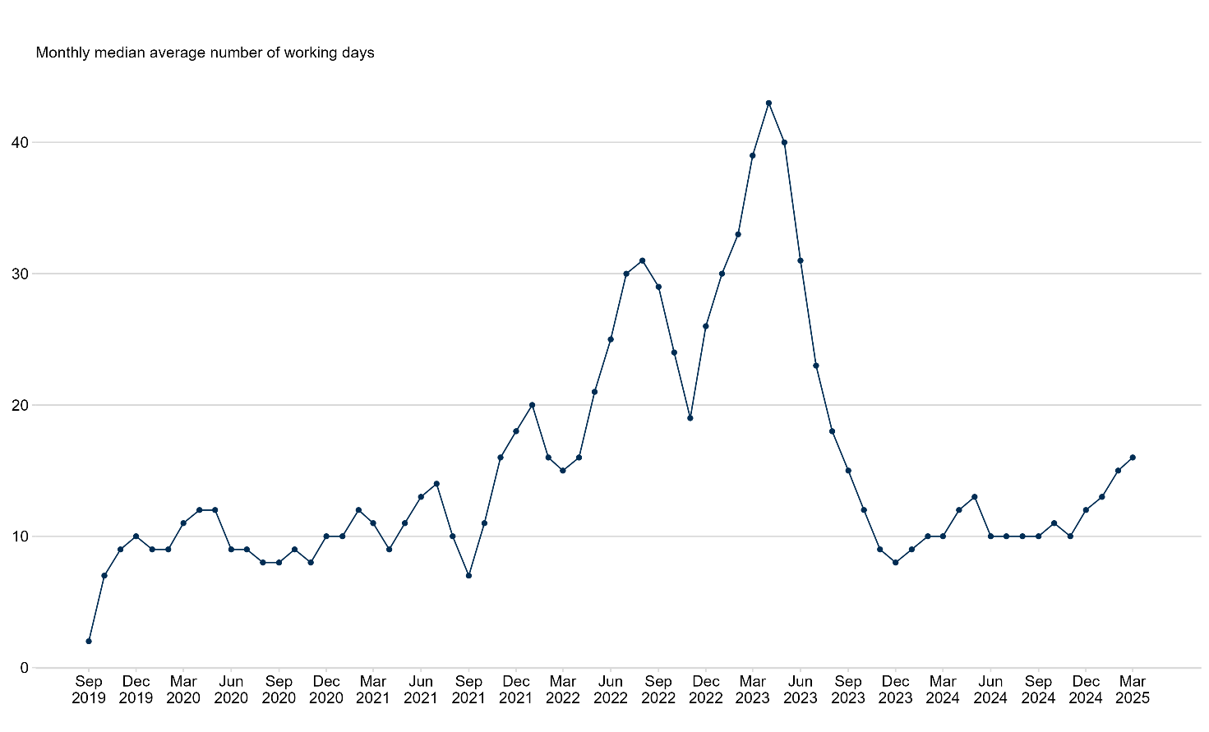

The total value of payments issued to 31 March 2025 was £60.1 million.

£12.2 million had been paid out to clients and funeral directors in the 2024/25 financial year. Of the payments issued this financial year, 63% were paid to funeral directors at the request of clients. The remaining 37% were paid directly to clients.

Figure 3: The number of payments being paid directly to a funeral director has been higher every month than those issued to clients, over the past fifteen months.
Payments issued by recipient, from January 2024 to March 2025.

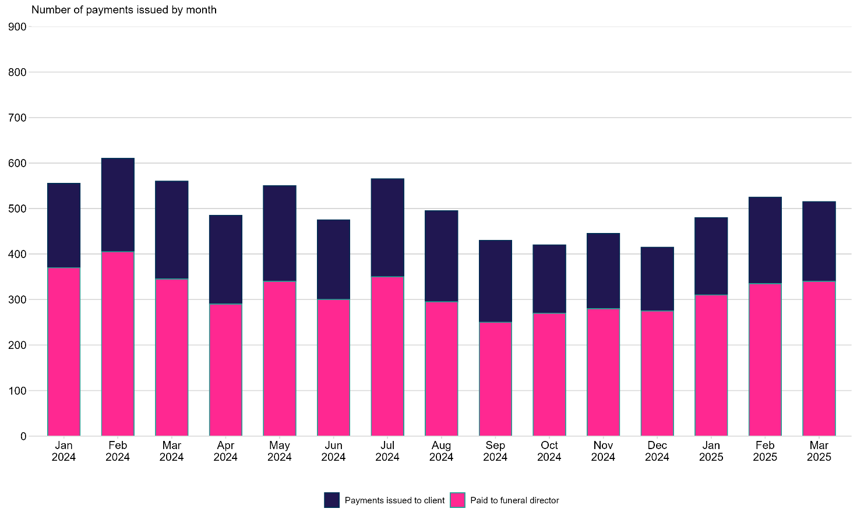

In total 32,065 payments were issued by 31 March 2025.

Of these, 5,780 payments with a mean average value of £2,103, were issued in the 2024/25 financial year. This is an increase from an average payment value of £1,974 in the 2023/24 financial year.

The vast majority of those paid were for cases where the person who had died was aged 18 or over.

For these cases, the mean average amount paid in the 2024/25 financial year was £2,118. This compares to £1,296 for those aged 17 or under.

In total, 30,820 individual clients had at least one payment issued since the launch of Funeral Support Payment.

5,735 of these clients have been paid in the 2024/25 financial year.

Up to 31 March 2025, 1,410 re-determinations requests were received.

In total, 1,400 of these re-determination requests have been completed. Of these, 54% were disallowed, 41% were allowed and 4% were withdrawn. The remaining 1% were for when a re-determination decision was not made.

The all-time median average response time for re-determinations was 12 working days.

This compares to the median average response time of 13 working days for re-determinations that were completed in the 2024/25 financial year.

In total, around 130 appeals were received by 31 March 2025.

85 of these appeals have been decided. Of these, 60 were not upheld in the clients’ favour, and 30 were upheld in the clients’ favour.

Background notes
As a result of the Scotland Act 2016 a wide range of powers, including welfare powers, have now been transferred to the Scottish Government and Scottish Parliament.

Social Security Scotland – the executive agency of the Scottish Government responsible for delivering social security benefits for Scotland – began taking applications for Funeral Support Payment on Monday 16 September 2019. This replaced the Funeral Expense Payment, which the Department for Work and Pensions ceased to deliver in Scotland on the same day.
Further details about the benefit can be found on the mygov.scot website.

Funeral Support Payment
The Funeral Support Payment is a cash payment to help towards the costs of a funeral. The payment will be made to an individual responsible for paying for the funeral or directly to a funeral director if the client requests this. The payment usually will not cover the full cost of the funeral, but it will help pay some costs. For example, burial, cremation or alkaline hydrolysis costs, applicant’s travel costs, transport costs to move the deceased person, document costs, medical costs and a set amount for ‘other funeral costs’ such as funeral director fees or a coffin.

Eligibility
To be eligible to qualify for Funeral Support Payment, the applicant must meet all eight eligibility statements below. If any of the following statements are not met, then the client will not be eligible:
- I live in Scotland.
- I have not already had help with funeral costs from the UK government for this funeral.
- I (or my partner) am getting at least one qualifying benefit. These are:
- Income Support
- Income Based Jobseekers Allowance
- Income related Employment and Support Allowance
- Pension Credit
- Child Tax Credit
- Disability or severe disability element of Working Tax Credit
- Universal Credit
- Housing Benefit
- I am applying after the person died, and up to six months after their funeral.
- The funeral is for someone who lived in the UK.
- I (or my partner) am responsible for paying for the funeral.
- It is reasonable* for me (or my partner) to accept responsibility for the funeral costs.
- The funeral is being held in the UK. We may also be able to award Funeral Support Payment for a funeral in the European Union, or Iceland, Liechtenstein, Norway or Switzerland in some circumstances, and anywhere in the world outside the UK in exceptional circumstances.

*Usually, it is reasonable for the nearest relative of the deceased person to accept responsibility for the funeral costs. A nearest relative could be a partner, child, parent or sibling. If the applicant or their partner is not the nearest relative, they will need to explain to Social Security Scotland when they apply why it is reasonable for them to have accepted responsibility for the funeral costs.
The Funeral Support Payment can help towards funeral costs of an adult aged 18 or older or a young person (aged 17 or under) including a child, a baby, or a stillborn baby. If a baby died before the end of 24 completed weeks of pregnancy, Funeral Support Payment cannot help towards these costs. If the baby was born alive and subsequently died before 24 completed weeks of pregnancy, Funeral Support Payment can help towards the funeral costs.
Further details about eligibility for Funeral Support Payment can be found at mygov.scot website.

Payment amount
The average payment issued by Social Security Scotland is referenced in both Table 6 and the Payments section of this publication. However, the actual amount a client will be paid is dependent on a number of factors, as outlined below.

Deceased person’s assets
The amount paid will depend on the amount of money left behind by the deceased person that is available to be used towards the funeral costs. This can come in the form of any assets in the deceased’s estate such as money, savings, other funds, insurance policies or money due from pensions, burial clubs or a pre-paid funeral plan or similar arrangement. Any such money from the deceased person, if available, will need to be used to pay for the funeral expenses. Assets are not taken into consideration, and no deductions will be made if the deceased person is aged 17 years old or under.
Before 2 December 2024, Social Security Scotland denied applications if assets in the deceased’s estate were available and sufficient to meet the costs of a funeral. From 2 December 2024 onwards, rather than denying an application, Social Security Scotland deduct available assets of the deceased from an award of Funeral Support Payment in all cases. This allows entitlement to be calculated and if there are sufficient assets in the deceased’s estate, this will result in a nil award.

Burial, cremation or alkaline hydrolysis costs
The amount paid will depend on the cost of burial or cremation in the local council area where the deceased person lived immediately prior to their death. The exact burial or cremation costs are known for different local council areas. This gives an indication of the likely costs that will be paid. More information on burial and cremation costs can be found on the mygov.scot website.
As it usually does not cost anything to bury or cremate a baby, child or young person aged 17 or under in Scotland, payments might be lower in these instances.
Although not currently available in Scotland, clients who meet the eligibility criteria can claim costs for funerals which involve alkaline hydrolysis, which is a new method of body disposal available outside the UK.

Funeral costs
Under The Social Security (Up-rating) (Miscellaneous Amendments) (Scotland) Regulations 2024, we uprated the ‘relevant figures’ for Funeral Support Payment by 6.7% for applications made on and after 1 April 2024 to 31 March 2025. The uprated standard flat rate payment is £1,257.75, which can be used to meet other funeral costs, such as the funeral car or funeral service. If the person who died had a pre-paid funeral plan, this amount will be reduced to £153.50.
The standard flat rate payments at different dates are shown below:

Date application was received | Amount (£)
16 September 2019 to 31 March 2021 | 1,000.00
1 April 2021 to 31 March 2022 | 1,010.00
1 April 2022 to 31 March 2023 | 1,070.60
1 April 2023 to 31 March 2024 | 1,178.75
1 April 2024 to 31 March 2025 | 1,257.75

Travel costs
The Funeral Support Payment can help towards the cost of one return journey by the client for the purpose of arranging the funeral or to attend the funeral. This can include travel by car, bus or train, and can include travel by taxi, boat and plane in certain circumstances. For the Funeral Support Payment to cover the cost of this journey, it must not exceed the cost of a return journey from the client’s home to the funeral location.

Transport costs to move the deceased person
The Funeral Support Payment can help with transport costs if the deceased person needs to be moved more than 49.7 miles from where the body is located to where the body will lie before the funeral within the United Kingdom. In some circumstances we will allow for transport costs from where the body is lying before the funeral to the funeral, for funerals in the European Union, or Iceland, Liechtenstein, Norway or Switzerland as well as the United Kingdom. We can also allow for transport costs from where the body is lying before the funeral to the funeral, for funerals anywhere in the world outside the UK in exceptional circumstances. Social Security Scotland can only help pay for the transport over 49.7 miles, including return transport. This amount is calculated based on information provided by the funeral director or taken from the funeral bill.
Document costs
The Funeral Support Payment can contribute towards the cost of death certificates for releasing money belonging to the deceased person; and medical certificates needed to bury or cremate the deceased person such as a Medical Certificate of Cause of Death (only needed for deaths outside Scotland).

Medical costs
The Funeral Support Payment can contribute towards the cost of certain medical procedures needed before the funeral can go ahead. For example, the removal of a pacemaker from the deceased person before they can be cremated.

Recovering payments
Social Security Scotland can recover any Funeral Support Payment award made either in part or in full if money becomes available from the deceased person's estate.

An example of an amount paid out
The deceased person was over 18 and lived in the Glasgow City Council area. They had £250 in personal savings that is available to be used towards the funeral costs, but no funeral plan. The removal of a pacemaker was required.
The person who is responsible for the funeral lives in Aberdeenshire and needed to travel from Aberdeenshire to Glasgow for the funeral. The expenses and deduction shown below detail how they would be able to get a total payment of £1,940.10:
Expense | Cost (£)
Cremation cost in Glasgow City | 849.00
Funeral costs | 1,257.75
Travel costs from Aberdeenshire to Glasgow | 58.00
Transport cost to move deceased person | 0.00
Document costs | 0.00
Medical costs to remove pacemaker | 25.35
Deduct deceased person’s accessible assets | -250.00

Application and decision making process
Applications can be made online (only by the applicant), by phone, and by paper form (‘application channel’). Also, it is possible for Funeral Support Payment applicants to submit evidence online. If a client is applying online, they will receive a message guiding them to a portal to upload their documents.
Social Security Scotland processes each application received and makes a determination whether to approve or deny the application. An application will be denied if the client is not eligible or provides insufficient evidence to demonstrate their eligibility to receive a Funeral Support Payment. An application will be authorised if the applicant is eligible and can provide the appropriate evidence to receive a Funeral Support Payment. Applicants may also withdraw their application before a determination is made. However, withdrawal of an application removes the right to a redetermination.
Social Security Scotland aims to process completed applications within ten working days of receiving all supporting evidence for an application, and they will make payment as soon as possible thereafter. Applications may take longer to process if copies of documents need to be requested and received from clients. This is less likely when applicants choose to work with a funeral director and provide Social Security Scotland with consent to contact that funeral director. This is because the funeral director often has most of the required information available and the payment can be made directly to the funeral director, if the client is eligible and consents for Social Security Scotland to pay the funeral director.
It should be noted that the measure of applications processed within ten working days included in this publication reflects the time between an application being received and a decision. It is not a measure of the time from all supporting evidence being received to decision. For further information on the calculation, see the processing times section of the background note.

Re-determinations and appeals
Funeral Support Payment applicants can ask Social Security Scotland to look again at a decision if their application is denied, or if they think the amount they are going to be paid is wrong. This is known as a re-determination. A request for a re-determination should be made within 31 calendar days of being notified of the determination. This is extended to up to 1 year when there is a good reason for lateness.
Social Security Scotland then has 16 working days to make the new determination. Funeral Support Payment applicants also have the right to appeal to a Tribunal if they do not agree with Social Security Scotland’s re-determination, or if Social Security Scotland is not able to make a re-determination within 16 working days.

About the data

How the data is collected
The data in this publication is sourced from Social Security Scotland’s case management system. The system holds information on all applications received, decisions and payments. Data about the applicant, their partner, and the deceased person is collected through the online application form, or is entered by client advisors during telephone applications, or the processing of paper applications. Information about the application outcome and payments is created in the case management system as an application is processed.
The information is held across multiple tables within the system. 100% extracts of administrative data are taken from this system every day for internal reporting purposes. Data cuts combine information from the different tables in the system into one daily extract that includes details of all Funeral Support Payment applications made since 16 September 2019.
To take into account backdating and delays between applications being authorised and payments being made, a data cut was taken on the first of the month one full month after the final date used in this publication, for example for data up to 11.59 pm 31 December 2024, a data cut on 1 February 2025 was used. Later data cuts may include additional retrospective changes to application details, including corrections to details in the case management system, and changes that have resulted from re-determinations and appeals.
When a re-determination or appeal is requested, the data in this publication will show the decision date, outcome, payment date and payment value after a re-determination or appeal has been decided. Where a re-determination or appeal has been requested but not decided, decision date, outcome, payment date and payment value will be updated to reflect information about the re-determination or appeal, rather than the original application.
Until March 2022, re-determinations and appeals were reported based on management information manually collected by the Client Experience team at Social Security Scotland. From April 2022 onwards, the figures reported in Table 10 for re-determinations are based on data extracted from the case management system.
Similarly, while information on appeals are still manually collected, from October 2023 onwards the figures reported in Table 11 for appeals are based on data extracted from the case management system. This is part of an ongoing piece of work to improve the reporting of re-determinations and appeals across all benefits.
Within our statistical reporting, key dates are used to assign applications received, applications processed, and payments issued to time periods. This is a different methodology to that used in financial reporting and, as a result, there may be differences in the values reported for a given time period.

Quality assurance
The data used to produce the official statistics are the same as the data extracted from the case management system on a daily basis that is used for internal reporting within Social Security Scotland. As such, the data is checked daily for consistency with previous extracts (i.e. do applications, decisions and payments figures increase as expected over time, and are they in proportion to each other) and compared to other sources of information such as the number of payment instructions reported by the finance team.
Additional quality assurance and cleaning has been carried out on the variables used in the official statistics:
- Check for duplicate and missing application references.
- Check that application dates, processing times and payment times are within the expected ranges.
- Check that payment date is present where a payment value is present.
- Check any postcodes that do not match to local authority areas – see Geography section.
Once the data is aggregated and copied into the publication and supporting Excel tables, the final statistics are quality assured by a different member of the statistics team. The lead statistician checks the final documents.

Revisions
Each updated publication of Funeral Support Payment statistics can include revisions of numbers of applications received, processed, processing times and payment values going back to September 2019. This is because each time figures are published they will be based from a new 100% data cut from the case management system, which can include retrospective changes to data going back to September 2019 as described in the How the data is collected section. Months that are more recent tend to be subject to a greater degree of revision than more distant ones.

Data quality

Rounding and disclosure control

Application and outcome figures have been rounded to the nearest five for disclosure control. Data has been suppressed where it would disclose fewer than five applications or payments. This is also the case with re-determinations and appeals data.

Missing and duplicate applications

The data comes from 100% data cut of the case management system.
The data cut was checked for applications where the fields relating to application date and the outcome and payment of the application were blank. These applications would represent temporary ‘prospect cases’, which are created when clients contact Social Security Scotland without a National Insurance number and are later replaced once a National Insurance number is received from the applicant. Any such applications are therefore duplicates and are excluded from the statistics.
Clients may make repeated applications to Funeral Support Payment in certain circumstances. For instance, if their initial application is withdrawn or denied. This means that there can be several applications from the same client in the data cut. For this publication, we have retained all of these applications.

Number of clients who have received at least one Funeral Support Payment

The total number of clients to have been issued at least one Funeral Support Payment is calculated by summing up the number of unique individuals who have received at least one Funeral Support Payment since the benefit launched on 16 September 2019.

Unverified information from application form

Information about the client and the deceased person is taken from the application form completed by the client or by a client advisor over the telephone. This information may contain errors because it has not been verified by comparison to other sources of information such as records held by the Department for Work and Pensions. This means, for example, that it is possible to have authorised applications where the original application form did not include complete details of the deceased but was later amended as the application was processed.
Delay between application authorised and payment

In this publication, the date that applications were processed by client advisors is the date used to produce statistics of processed applications by month. After applications are authorised for payment by client advisors, a manager approves the decision, and then a payment is issued. In some cases, payments will be issued on the same day that payments are authorised by client advisors, however in other cases there can be a delay before payments are issued. Clients should receive money in their nominated account within four working days after payment is issued.
In this publication, we report on the value of payments that have been issued by the end of each month and not the payments successfully received by the applicants.

Application channel

Application channel is automatically entered into the case management system for online applications and manually entered for applications taken by phone or paper. If ever an application channel has been manually entered incorrectly, the application channel will be classed as ‘unknown’.

Geography

Applications are assigned to local authority area by postcode using a Scottish Government lookup file. For some applications, the postcode will not match to the lookup file. This can be because the postcode is not in a Scottish local authority area, or because the postcode has been introduced too recently to appear on the lookup file, for example if a property is in a new development. For postcodes that could not be matched to a Scottish local authority area, the postcode area was used to check whether the postcode was in Scotland or elsewhere. Non-matching postcodes from Scottish border postcode areas (postcodes starting ‘DG’ and ‘TD’) were also checked individually and assigned to Scottish local authorities as ‘non-Scottish postcodes’ manually.
Postcodes are linked to client profiles and data extracts are automatically updated in the case of a client changing address. As a result, postcodes reflect the latest address of clients and may not be the same as the address at the time of application. Therefore, a small number of addresses may not reflect the correct local authority area at the time of application, decision or payment.
A small number of applications did not include address information and therefore could not be matched to a local authority area or country.
Re-determinations and Appeals data and methodology review

The dataset which underpins all re-determinations and appeals reporting in this publication has been updated as part of a continuous improvement exercise to ensure the statistics continue to be robust and transparent for users.

The impact of this change varies across benefits. For Funeral Support Payment there are around 5 more cases recorded in the new data extract compared to the old data extract. This is less than 1% of the total 1,410 re-determinations received as of 31 March 2025.

At the same time, small changes have been made to how we present the statistics to better reflect their contents and improve the comparability of reporting across all benefits.

The column “Re-determination decision not made” has been added to the tables. Details on the contents can be found in the table notes. This information has previously been available in disability statistics publications and is included here to improve consistency in reporting. The column “Re-determinations completed” now includes these figures. This may impact the “Percentage of completed redeterminations” columns, which use the total completed as the denominator for their calculation. The change results in 15 additional re-determinations being reported between September 2019 and March 2025.

The column heading “Completed re-determinations which are allowed or partially allowed” has been changed to “Completed re-determinations which are allowed”. All cases decided in favour of the client are now classed as allowed. There is no impact on the reported figures.

The column heading “Appeal hearings taking place” has been changed to “Appeals decisions made”. To be categorised as Upheld or Not Upheld, a decision must have been made. There is no impact on the reported figures.

Removal of re-determinations rate measures

Over time the size and complexity of the benefits being administered by Social Security Scotland has continued to evolve. There were known limitations in the calculation of “re-determinations as a percentage of application decisions made” which are having an increasing impact on reporting.
To ensure that our published statistics continue to meet high standards of trustworthiness and quality for our users, “re-determinations as a percentage of all decisions processed” was removed from the previous publication and this remains the case until further options for reporting can be explored. We cannot currently put a timescale on when an alternative solution may be available.
For more information, please see our Data and Methodology Changes document which details ongoing data issues and revisions made to the statistics. As with all our statistics, we encourage users to get in touch if they have any feedback regarding these statistics or any ongoing continuous improvement.

Effect of re-determinations
Application decision dates, outcomes and payment amounts are updated to reflect information about re-determinations and appeals as described in the How the data is collected section. Information in tables about decisions, outcomes and payments should therefore be viewed as the final decision, outcome and payment value, after a re-determination request or appeal has been received and/or decided. This excludes the processing times table, where applications with re-determinations and appeals have been removed from the processing times calculations.
Processing time
Processing time is the number of days from the application being received to a decision being made or the application being withdrawn. It includes time spent waiting to receive copies of documents from clients or funeral directors. It does not include additional time to make payments. It is calculated in working days. Weekends and public holidays are excluded, even if applications were processed by staff working overtime on these days. The time of day that an application was received or processed is not taken into account.
Applications that are flagged as having had a re-determination request are excluded from processing time calculations where possible. This is because the decision dates for these applications may represent the re-determination decision date which can be some time after the original decision date. The number of applications in the processing times table is therefore lower than the number of applications shown as processed or decided in other tables.
The methodology for excluding applications with a re-determination request was updated in May 2025. For reporting from April 2022 onwards, this change results in an improved identification of such cases for exclusion. Re-determination reporting prior to April 2022 was based on manually collated information which does not allow for cases to be identified and excluded.
Re-determinations are a very small proportion of the total applications processed, and the initial average processing times for applications that go on to re-determination or appeal compared to other applications should not differ from all other applications. Therefore, removal of these should not affect the average processing times shown in the table.
Processing time is only calculated for applications that were decided within the period being reported on. Data is presented by the month of decision rather than month the application was received.

Future developments
We will be seeking users’ views on the content of this publication to ensure it best meets their requirements. If you have any comments or suggestions that you would like to provide us, please email MI@socialsecurity.gov.scot.

Information on Department for Work and Pensions Funeral Expense Payment statistics
Department for Work and Pensions publish information about Funeral Expense Payment in the Social Fund annual report at Great Britain level only. Department for Work and Pensions also publishes annual expenditure for Funeral Expense Payments at Great Britain level in their Benefit expenditure and caseload tables.

Related Social Security Scotland publications
Statistics published by Social Security Scotland can be found at Social Security Scotland statistics.
An Official Statistics publication for Scotland

Official Statistics are produced to high professional standards set out in the Code of Practice for Official Statistics. They undergo regular quality assurance reviews to ensure that they meet customer needs and are produced free from any political interference.

Correspondence and enquiries
For enquiries about this publication, please contact:
Ian Gardiner
Social Security Statistics
E-mail: MI@socialsecurity.gov.scot

For general enquiries about Scottish Government statistics please contact:
Office of the Chief Statistician
E-mail: statistics.enquiries@gov.scot

How to access background or source data

The data collected for this statistical bulletin:
- are available via an alternative route. Summary tables are available at:
Social Security Scotland statistics.
- may be made available on request, subject to consideration of legal and ethical factors. Please contact MI@socialsecurity.gov.scot for further information.

Complaints and suggestions
If you are not satisfied with our service or have any comments or suggestions, please write to the Chief Statistician, St Andrew’s House, Regent Road, Edinburgh, EH1 3DG, e-mail statistics.enquiries@gov.scot.

If you would like to be consulted about statistical collections or receive notification of publications, please register your interest at ScotStat.

Details of forthcoming publications can be found on the Social Security Scotland website and Scottish Government website.

Crown Copyright
You may use or re-use this information (not including logos) free of charge in any format or medium, under the terms of the Open Government License.

The Code of Practice for Statistics is available on the UK Statistics Authority website.
The forthcoming publication timetable is available on Social Security Scotland website.
More information on official statistics in development is available on the UK Statistics Authority website.
Information about the population of the local authorities can be found on the National Records of Scotland website.
This difference is partly attributable to increases in the standard flat rate paid to clients (see the background section for more information on payments).
A client refers to a person who has applied for the benefit, regardless of the payment being made to them or to the funeral directors.
Re-determination decision not made includes those which were invalid or exceeded the deadline and the client opted to cease the re-determination process and move to appeal.
If the client is relying on a backdated award of qualifying benefit that relates to at least one day in the 6 month period, then they can apply within 20 working days after the end of the 6 month period (provided they are applying within 3 months of being informed of the backdated award). Also, clients can now apply after the original 6 months following the funeral if the reason for the delay in applying is linked to Covid-19.
Under the Social Security (Up-rating) (Miscellaneous Amendment) (Scotland) Regulations 2024, we have uprated the “relevant figures” for Funeral Support Payment in line with inflation for applications made on or after 1 April 2024.

