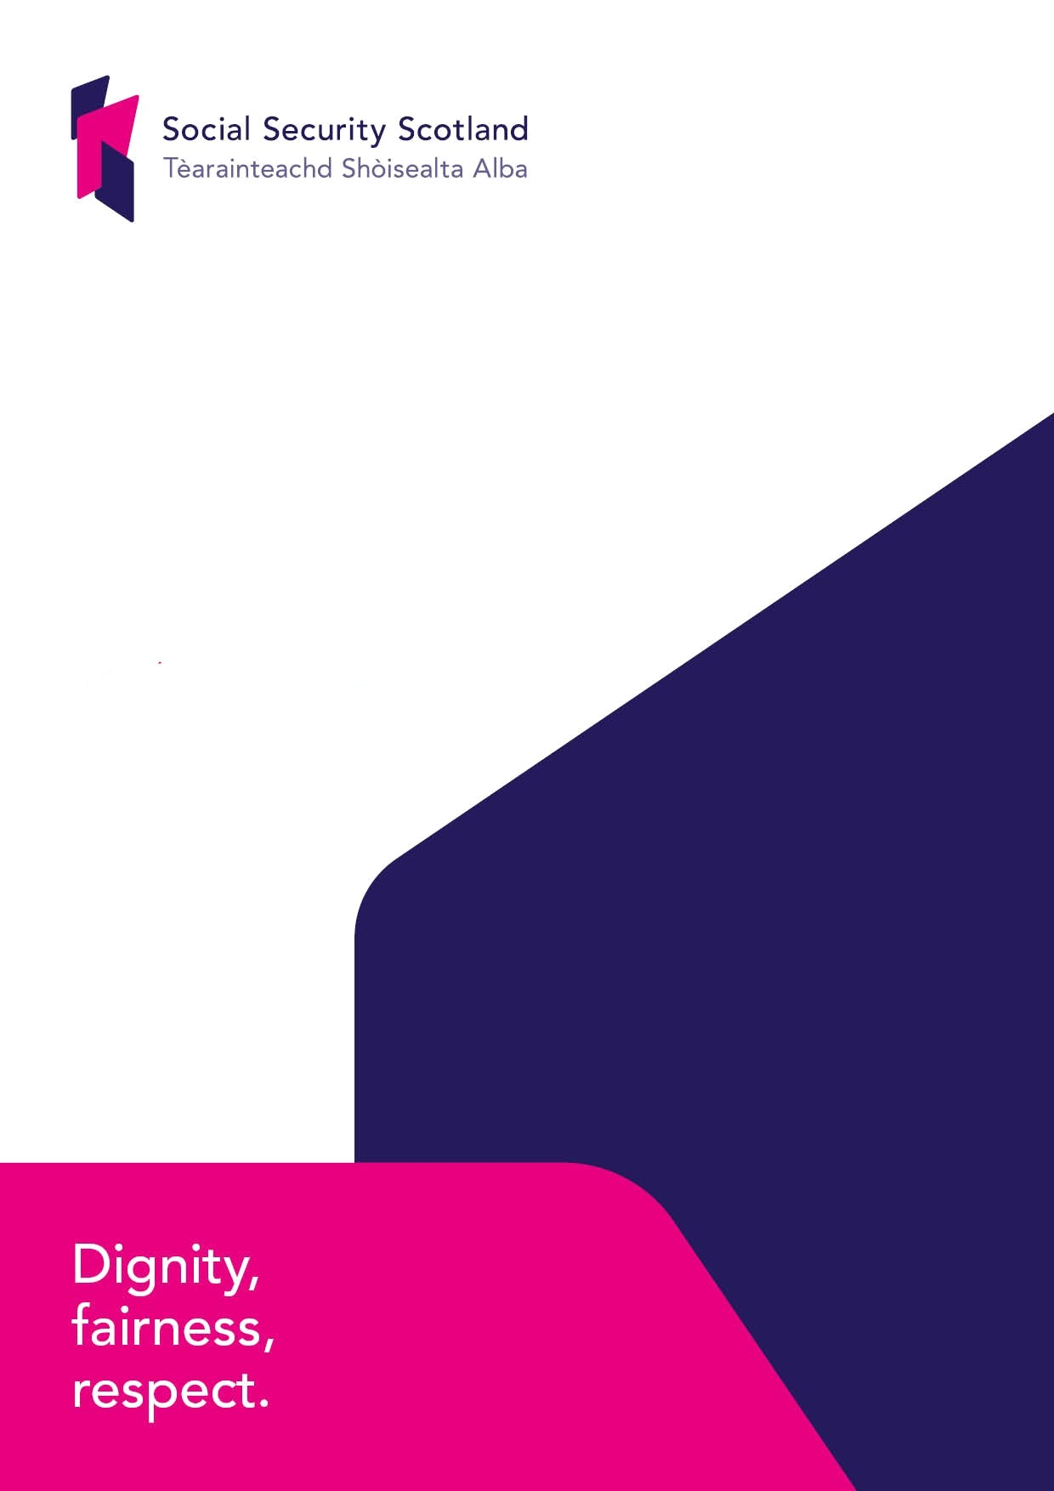

**Social Security Scotland**

Guide to Information

**Social Security Scotland**

**Guide to Information**

**May 2025**

Table of Contents

* Introduction
* Purpose
* Social Security Scotland
* Availability and formats
* Publications
* Exempt Information
* Copyright and re-use
* Charges
* Advice and assistance
* Duration
* Classes of Information

Introduction

The [Freedom of Information (Scotland) Act 2002](https://www.legislation.gov.uk/asp/2002/13/contents) (the Act) and the Environmental Information (Scotland) Regulations 2004 are the key laws which provide individuals with a right to request any recorded information held by Scotland’s public authorities. Anyone can use this right, and information can only be withheld where the Act expressly permits it.   
  
The Act requires Scottish public authorities to adopt and maintain a publication scheme. Authorities have a duty to:

* publish the classes of information that they make routinely available; and
* tell the public how to access the information they publish and whether information is available free of charge or on payment.

A class is a group of information having one or more common features such as subject or origin.

The Scottish Government is the named public authority in the Act. The Scottish Government has adopted the [Model Publication Scheme](http://www.itspublicknowledge.info/ScottishPublicAuthorities/PublicationSchemes/TheModelPublicationScheme.aspx) developed by the Scottish Information Commissioner. The Model Publication Scheme developed by the Commissioner can be viewed [online](http://www.itspublicknowledge.info/ScottishPublicAuthorities/PublicationSchemes/PublicationSchemesHome.aspx) or [by contacting us.](https://www.socialsecurity.gov.scot/contact)   
  
Social Security Scotland will contribute to the Model Publication Scheme by:

* using the Model Publication Scheme as its publication scheme, and accepting any updates to the Model Publication Scheme, without amendment;
* publishing the information, including environmental information, we hold which falls within the classes of information;
* ensuring that the way we publish information meets the Model Publication Scheme Principles;
* producing a Guide to Information which sets out:

(a) the information the authority publishes through the Model Publication Scheme;

(b) how to access it;

(c) whether there is a charge for it; and

(d) how to get help to access information.

Purpose

The purpose of this Guide to Information is to:

* allow the public to see what information is available (and what is not available) in relation to each class;
* state what charges may be applied;
* explain how to find the information easily;
* provide contact details for enquiries and to get help with accessing the information; and
* explain how to request information we hold that has not been published.

Social Security Scotland  
Social Security Scotland is an Executive Agency of the Scottish Government. We started operating in September 2018. Our purpose is to administer the Scottish social security system effectively, in accordance with the principles in the [Social Security (Scotland) Act 2018](http://www.legislation.gov.uk/asp/2018/9/contents/enacted) and our [Charter.](https://www.socialsecurity.gov.scot/reporting/publications/our-charter-1)  
As an Executive Agency, the Scottish Government’s [“6 principles of Freedom of Information”,](https://www.gov.scot/publications/guide-to-information/) underpin our approach. These principles make clear the Scottish Government’s commitment to open government and publishing information routinely whenever possible. We have also considered the types of information which are requested from Social Security Scotland routinely and, where possible, sought to publish information proactively.

We are working together with partners in the Scottish Government and beyond to deliver the benefits devolved to Scotland. Once fully working, the Scottish Government will directly deliver 17 benefits through Social Security Scotland of which 7 are completely new forms of support. A list of the benefits we currently deliver can be found [here](https://www.socialsecurity.gov.scot/benefits).

Social Security Scotland has staff located across Scotland to support individuals to access benefits. The head office is in Dundee and a further office is in Glasgow. Social Security Scotland are committed to publishing all information which we hold which falls within the classes of information in the scheme. The information we publish through the model publication scheme is, wherever possible, available on our website. Dignity, fairness and respect are at the core of everything we do. We demonstrate these values by making our work as transparent and accountable as possible.

General information on Social Security Scotland:

[Where you can find us](https://www.socialsecurity.gov.scot/contact/how-to-find-us)

[Our service](https://www.socialsecurity.gov.scot/about)

[Make a request for information](https://www.socialsecurity.gov.scot/about/publication-scheme-and-freedom-of-information)

[The Social Security (Scotland) Act 2018](https://www.legislation.gov.uk/asp/2018/9/contents)

[Contact Us](https://www.socialsecurity.gov.scot/contact)

[Our latest publications](https://www.socialsecurity.gov.scot/publications)

Availability and formats  
The information we publish through the model scheme is, wherever possible, available on our website. We offer alternative arrangements for people who do not want to, or cannot, access the information online or by coming along to our premises. For example, we can usually arrange to send information to you in paper copy. Whilst we do not intend to charge for this, there may be a charge where the volumes requested or the time to prepare the information is more than reasonable. To request information in an alternative format you can contact us in several ways. These can be found later in this guide.

Publications

All publications by Social Security Scotland can be found at the [Publications page](https://www.socialsecurity.gov.scot/publications).

The documents are searchable and can be filtered by topic, type and date.

Exempt Information  
All information published in this guide can be accessed either through our website, or by asking us for it.

Our aim in maintaining this publication scheme is to be as open as possible. You should note, however, that there may be circumstances where information will be withheld from publication. Information will only be withheld where the Act or, in the case of environmental information, the Environmental Information (Scotland) Regulations 2004 expressly permits it. This could include where the information’s disclosure would breach the law of confidentiality, harm an organisation’s commercial interests or endanger the protection of the environment. Information may also be withheld if it is another person’s personal information and its release would breach the data protection legislation.

Where we withhold information we will remove it before publication and explain why.

Copyright and re-use  
The material contained within Social Security Scotland website and publications is © Crown copyright 2019. You may use and re-use the information featured on this website free of charge in any format or medium, under the terms of the [Open Government Licence.](http://www.nationalarchives.gov.uk/doc/open-government-licence/version/3/) You may not use or re-use logos which are used to identify Social Security Scotland.

Images and videos are subject to Crown copyright protection unless otherwise indicated. Any materials on this site, for example some photographs and videos which are identified as the copyright of a third party are not covered by Crown copyright. It is your responsibility to obtain permission or other authorisation to use such material from the copyright holder. If you are unsure about copyright of material on this site please [contact us](https://www.socialsecurity.gov.scot/contact-us).

For further information on Crown copyright policy and licensing arrangements see the National Archives [guidance.](https://www.nationalarchives.gov.uk/information-management/re-using-public-sector-information/regulations/)  
  
Charges  
In accordance with the social security principles that are set out in the first section of the Social Security (Scotland) Act 2018, we do not intend to charge for our publications where the cost is reasonable. If we consider the costs incurred not to be reasonable, we may charge for providing information to you e.g., photocopying and postage, but we will charge you no more than it costs us to do so. We will always tell you what the cost is before providing the information to you.

If applying a charge, postage costs will be recharged at the rate we paid to send the information to you. When providing copies of pre-printed publications, we will charge no more than the cost per copy of the total print run. We do not pass on any other costs to you in relation to our published information.

Advice and assistance  
You can [contact us](mailto:foi@socialsecurity.gov.scot) for assistance with any part of this Guide to Information. We will also tell you how to ask for information that we do not publish or how to complain if you are dissatisfied with any aspect of this publication scheme.

Duration  
Where available and still current, information will be accessible through this Guide to Information for at least the current and previous two financial years. If you would like to see previous versions, please [contact us](mailto:foi@socialsecurity.gov.scot) for that information.

This Guide to Information was last updated in March 2025. It will be reviewed twice a year.

Classes of Information   
We publish information that we hold within the following classes:

* Class 1: About Social Security Scotland;
* Class 2: How we deliver functions and services;
* Class 3: How we take decisions;
* Class 4: What we spend;
* Class 5: How we manage our resources;
* Class 6: How we procure goods and services;
* Class 7: How we are performing;
* Class 8: Our commercial publications; and
* Class 9: Our open data

Class 1: About Social Security Scotland

Information on how Social Security Scotland is run.

* [Our Vision and Values](https://scotsconnect.sharepoint.com/sites/socialsecurityscotland-WhoWeAre/SitePages/Vision-and-values.aspx)
* [Agency Model Framework](https://www.socialsecurity.gov.scot/reporting/publications/social-security-scotland-model-framework)
* [Our Executive Team](https://www.socialsecurity.gov.scot/about/governance/our-executive-team)
* [Executive Team/Non-Executive Members Register of Interests](https://www.socialsecurity.gov.scot/reporting/publications/executive-team-non-executive-register-of-interests-2024-25)
* [Our Executive Advisory Body](https://www.socialsecurity.gov.scot/about/governance/our-executive-advisory-body)
* [Our Portfolio Sponsor](https://www.socialsecurity.gov.scot/about/governance/portfolio-sponsor-meetings)
* [Our Audit and Assurance Committee](https://www.socialsecurity.gov.scot/about/governance/audit-and-assurance)
* [Background to Social Security Scotland](https://www.socialsecurity.gov.scot/about)
* [The benefits we deliver](https://www.socialsecurity.gov.scot/benefits)

Information on our corporate planning.

* [Social Security Scotland’s Corporate Plan](https://www.socialsecurity.gov.scot/reporting/publications/corporate-plan-2024-2027)

Information on our external relations.

* [Stakeholder Resources](https://www.socialsecurity.gov.scot/guidance-resources/resources/style-writing-guide)
* [Upcoming Stakeholder Engagement Events](https://www.socialsecurity.gov.scot/news-events)
* [Guidance](https://www.socialsecurity.gov.scot/guidance-resources/guidance)

Class 2: How we deliver our functions and services  
Information about our work, our strategy and policies for delivering functions and services and information for our service users.

Information on our functions.

* [Our Charter](https://www.socialsecurity.gov.scot/reporting/publications/our-charter-1)
* [Our Business Plan](https://www.socialsecurity.gov.scot/reporting/publications/business-plan-2024-2025)
* [Our Counter Fraud Strategy](https://www.socialsecurity.gov.scot/reporting/publications/counter-fraud-strategy)
* [Our Error Control Strategy](https://www.socialsecurity.gov.scot/reporting/publications/error-control-strategy)
* [Our Debt Management Strategy](https://www.socialsecurity.gov.scot/reporting/publications/debt-management-strategy)
* [Code of Practice for Investigations](https://www.socialsecurity.gov.scot/reporting/publications/code-of-practice-for-investigations)
* [Our Digital Strategy](https://www.socialsecurity.gov.scot/about/strategies-and-plans/digital-strategy)
* [Our Corporate Parenting Plan](https://www.socialsecurity.gov.scot/reporting/publications/our-corporate-parenting-plan)
* [Corporate Governance](https://www.socialsecurity.gov.scot/about/governance)
* [Our Corporate Plan](https://www.socialsecurity.gov.scot/reporting/publications/corporate-plan-2024-2027)
* [Our Privacy Statement](https://www.socialsecurity.gov.scot/privacy-statement)
* [Our Community Benefits Strategy](https://www.socialsecurity.gov.scot/reporting/publications/social-security-scotland-community-benefits-strategy-2024-2027)
* [Corporate Assurance – Equality Impact Assessment](https://www.socialsecurity.gov.scot/reporting/publications/social-security-scotland-corporate-assurance-equality-impact-assessment-ikm-platform)

Information on our services.

* [Benefits](https://www.socialsecurity.gov.scot/benefits)
* [Service Design and Delivery](https://www.socialsecurity.gov.scot/about/strategies-and-plans/service-design)
* [Our Inclusive Communications Commitment](https://www.socialsecurity.gov.scot/about/inclusive-communications)
* [Stakeholder Resources Including Toolkits](https://www.socialsecurity.gov.scot/guidance-resources/resources)
* [How to make a complaint](https://www.socialsecurity.gov.scot/contact/feedback/how-to-make-a-complaint)
* [Complaints Handling Process](https://www.socialsecurity.gov.scot/asset-storage/production/downloads/Social-Security-Scotland-How-to-Make-a-Complaint-for-Clients.docx)
* [Equality Strategy](https://www.socialsecurity.gov.scot/about/strategies-and-plans/equality-outcomes)
* [Mainstreaming Equality Progress Report](https://www.socialsecurity.gov.scot/reporting/publications/mainstreaming-equality-progress-report-2023)

Class 3: How we take decisionsInformation about the decisions we take, how we make decisions and how we involve others.

* [Executive Advisory Body Minutes](https://www.socialsecurity.gov.scot/publications?keyword=&pubtopics%5B%5D=executive-advisory-body&pubtypes%5B%5D=meeting-minutes&startday=&startmonth=&startyear=&endday=&endmonth=&endyear=)
* [Audit and Assurance Committee Minutes](https://www.socialsecurity.gov.scot/publications?keyword=&pubtopics%5B%5D=audit-and-assurance-committee&pubtypes%5B%5D=meeting-minutes&startday=&startmonth=&startyear=&endday=&endmonth=&endyear=)
* [Portfolio Sponsor Minutes](https://www.socialsecurity.gov.scot/publications?keyword=&pubtopics%5B%5D=portfolio-sponsor&pubtypes%5B%5D=meeting-minutes&startday=&startmonth=&startyear=&endday=&endmonth=&endyear=)
* [Client Panels Newsletter](https://www.socialsecurity.gov.scot/search?query=client+panels+newsletter)
* [Inclusive Communications – External Stakeholder Reference Group Meetings](https://www.socialsecurity.gov.scot/search/p2?query=inclusive+communications)

Class 4: What we spend  
Information about our strategy for, and management of, financial resources in sufficient detail to explain how we plan to spend public money and what has been spent.

Social Security Scotland has been operational since September 2018.

* [Social Security Scotland’s Annual Report and Accounts](https://www.socialsecurity.gov.scot/search?query=annual+report)
* [Annual Procurement Report](https://www.socialsecurity.gov.scot/search?query=Social+Security+Scotland+Annual+Procurement+Report)
* [Electronic Purchasing Card Expenditure](https://www.socialsecurity.gov.scot/search?query=electronic+purchasing+card+transactions)
* [Transactions over £25k](https://www.socialsecurity.gov.scot/search?query=transactions)
* [Public Services Reform (Scotland) Act 2021 Publication](https://www.socialsecurity.gov.scot/asset-storage/production/downloads/Social-Security-Scotland-Corporate-Finance-Public-Reforms-Act-2010.pdf)
* [Annual Report Local Authority Breakdown](https://www.socialsecurity.gov.scot/reporting/publications/social-security-scotland-annual-report-local-authority-breakdown-2023-2024)

The Electronic Purchasing Card shows items of expenditure over £500 made by Scottish Government including Social Security Scotland.

Class 5: How we manage our resourcesInformation about how we manage the people, physical and information resources of the authority.

People

* [Social Security Scotland Workforce Information](https://www.socialsecurity.gov.scot/about/statistics/social-security-scotland-statistics-publications)
* [Social Security Scotland client diversity and equalities analysis](https://www.socialsecurity.gov.scot/search?query=Social+Security+Scotland+client+diversity+and+equalities+analysis)

Information

* [Statistics and Research](https://www.socialsecurity.gov.scot/publications?keyword=&pubtypes%5B%5D=statistics&startday=&startmonth=&startyear=&endday=&endmonth=&endyear=)
* [Statistics: Publications](https://www.socialsecurity.gov.scot/about/statistics/social-security-scotland-statistics-publications)

Class 6: How we procure goods and services  
Information about how we procure goods and services, and our contracts with external providers.

* [Social Security Scotland - Procurement and Commercial](https://www.socialsecurity.gov.scot/about/procurement-and-commercial)
* [Our Corporate Procurement Strategy](https://www.socialsecurity.gov.scot/asset-storage/production/downloads/Social-Security-Scotland-Corporate-Procurement-Strategy-2024-2027_2024-12-20-131435.pdf)

Social Security Scotland contracts are published on the [Public Contracts Scotland](https://www.publiccontractsscotland.gov.uk/Contracts/Contracts_Search.aspx) website.

Class 7: How we are performingInformation about how the authority performs as an organisation, and how well it delivers its functions and services.

* [Insights Research Findings](https://www.socialsecurity.gov.scot/search?query=Insights+Research)

One of the key indicators of our performance is the Charter Measurement Framework. This comprehensive series of measures was co-designed with key stakeholders, including those with lived experience of the benefits system.

* [Measuring Our Charter](https://www.socialsecurity.gov.scot/reporting/publications/charter-measurement-framework-update-2024-2029)
* [Charter Research](https://www.socialsecurity.gov.scot/reporting/publications/charter-research-2023-2024)

Management information, research and statistics on the devolved benefits Social Security Scotland is responsible for delivering is published on a regular basis.

Background to our reporting process.

* [Annual Report](https://www.socialsecurity.gov.scot/search?query=annual+report)
* [Social Security Scotland Client Survey](https://www.socialsecurity.gov.scot/search?query=client+survey)
* [Local Delivery Service Survey](https://www.socialsecurity.gov.scot/reporting/publications/local-delivery-service-2023)

Class 8: Our commercial publicationsThis class refers to information packaged and made available for sale on a commercial basis. Social Security Scotland holds no information under this class.

Class 9: Our Open DataOpen data made available by Social Security Scotland as described by the Scottish Government’s [Open Data Resource Pack.](https://www.gov.scot/publications/open-data-resource-pack-9781786524034/) We publish Open Data as part of the Official Statistics Process. Part of the Code of Practice for Official Statistics is the orderly release of statistics:

* Dates for Publication are available in the [Forthcoming Publications list](https://www.socialsecurity.gov.scot/publications/statistics) on the Social Security Scotland website.
* Statistics are released at 9:30 on a weekday
* Policy, press or ministerial statements referring are issued separately from, and contain a prominent link to, the source of statistics.
* High level data is published as official statistics 12 weeks after each benefit is launched
* Most of our publications are quarterly
* We publish open date within our published excel tables for each of our benefits, which can be found on Social Security Scotland’s official statistics webpage [Social Security Scotland - Statistics](https://www.socialsecurity.gov.scot/publications/statistics). We also publish open data on the Scottish Government’s open access site [statistics.gov.scot.](https://statistics.gov.scot/home) It includes details on all statistics produced by Social Security Scotland including intermediate geographies for Scottish Child Payment caseload.
* Five-star Open data is released within one month of the official statistics publication.

Data is published in the [five star](https://5stardata.info/en/) format on the open data publishing platform <https://statistics.gov.scot/home>.

You can search by [Benefit Name](https://www.socialsecurity.gov.scot/benefits) or [Social Security Scotland](https://www.socialsecurity.gov.scot).

You can browse all [Social Security Scotland Open Data](https://statistics.gov.scot/resource?uri=http%3A%2F%2Fstatistics.gov.scot%2Fdef%2Fconcept%2Ffolders%2Forganisations%2Fsocial-security-scotland).