# Summary statistics for Carer’s Allowance at November 2018 and Carer's Allowance Supplement, October eligibility date 2018

## 

Frequency of publications

The next publication, covering the Carer’s Allowance at February 2019 and Carer’s Allowance Supplement, October 2018 eligibility update will be released in August 2019.

Carer’s Allowance Supplement, April eligibility 2019 will be released in the following publication in November 2019.

Under the Code of Practice for Official Statistics[1] we publish a timetable of statistical releases for the twelve months ahead[2].

# Introduction

This publication provides information on recipients of Carer’s Allowance in Scotland at November 2019 and recipients of the Carer's Allowance Supplement (CAS) to the October eligibility date 2018. This supplement is given to people in Scotland who receive Carer's Allowance on the CAS eligibility dates. These are two dates each year - one in April and one in October - which are set by the Scottish Government.

All tables and charts relating to this publication can be found at:

[www2.gov.scot/Topics/Statistics/Browse/Social-Welfare/SocialSecurityforScotland](https://www2.gov.scot/Topics/Statistics/Browse/Social-Welfare/SocialSecurityforScotland)

These statistics are being published as experimental statistics, which are defined in the Code of Practice for Statistics as "*new official statistics undergoing evaluation. They are published in order to involve users and stakeholders in their development and as a means to build in quality at an early stage.*" These statistics have not yet been assessed by the UK Statistics Authority, so have not been designated as National Statistics[3].

# Carer’s Allowance at November 2018

* At the end of November 2018, there were 75,437 carers in Scotland in receipt of Carer’s Allowance (CA). This is an increase of three per cent since the previous year (72,942 at the end of November 2017) and a negligible decrease (less than one per cent) since the last quarter (75,805 at the end of August 2018).
* A further 46,129 carers were entitled to CA but did not receive a CA payment, the majority of these carers (79 per cent) were over the State Pension age, so may have been eligible to a State Pension with a value equal to or exceeding their weekly rate of Carer's Allowance (See Background Note).
* Over two thirds of CA payments (69 per cent) were made to female carers and nearly a third (31 per cent) of payments were made to male carers.
* Of the CA claimants in receipt of payments 44 per cent were aged over 50, whereas only 12 per cent were under the age of 30.
* Two thirds of claimants (68 per cent) have been receiving CA payments for over two years, with 38 per cent receiving CA payments for over five years.
* The average CA payment was £64.53 a week, which is slightly less than the maximum £66.15 for new claimants (See Background Note).

**Summary Panel: Carer’s Allowance payments at November 2018**

# October 2018 Eligibility Date

* 75,760 CAS payments have been made to carers who were eligible in October 2018. Each payment was £221, giving a total expenditure of £16.7 m.
* Over two thirds of CAS payments were made to female carers (52,245 payments, 69 per cent), while 31 per cent of payments were made to male carers (23,460 payments).
* Almost four times as many CAS payments were made to carers aged over 50 (33,610 payments, 44 per cent), compared to those aged under 30 (8,735, 12 per cent) **[Chart 1]**. The average age of carers in receipt of CAS payments was 46.
* Only a small proportion of CAS payments were made to carers aged 65 and over (770 payments, one per cent ) or under 18 (255 payments, less than one per cent) **[Chart 1]**.
* The local authorities with the greatest numbers of carers receiving CAS payments were Glasgow City (12,380, 16.3 per cent), North Lanarkshire (6,410, 8.5 per cent), Fife (5,660, 7.5 per cent), South Lanarkshire (5,435, 7.2 per cent) and City of Edinburgh (4,500, 5.9 per cent). **[Table 2, Chart 2]**.

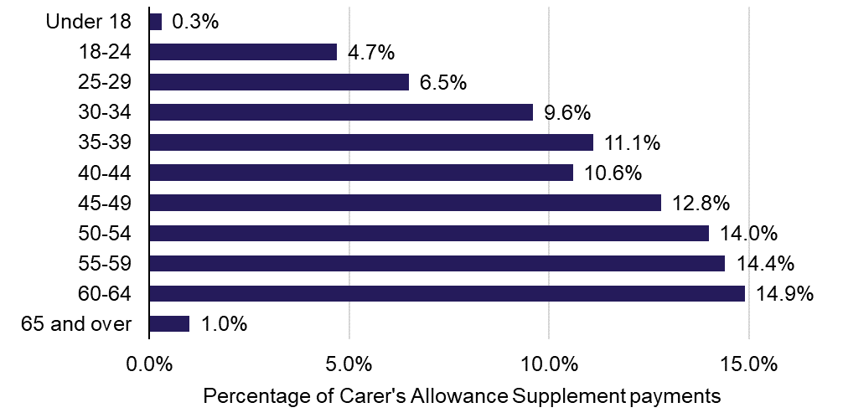**Chart 1: Percentage of Carer’s Allowance Supplement payments by age band – October 2018 eligibility date**

**Chart 2: Percentage of Carer’s Allowance Supplement payments by Local Authority – October 2018 eligibility date**

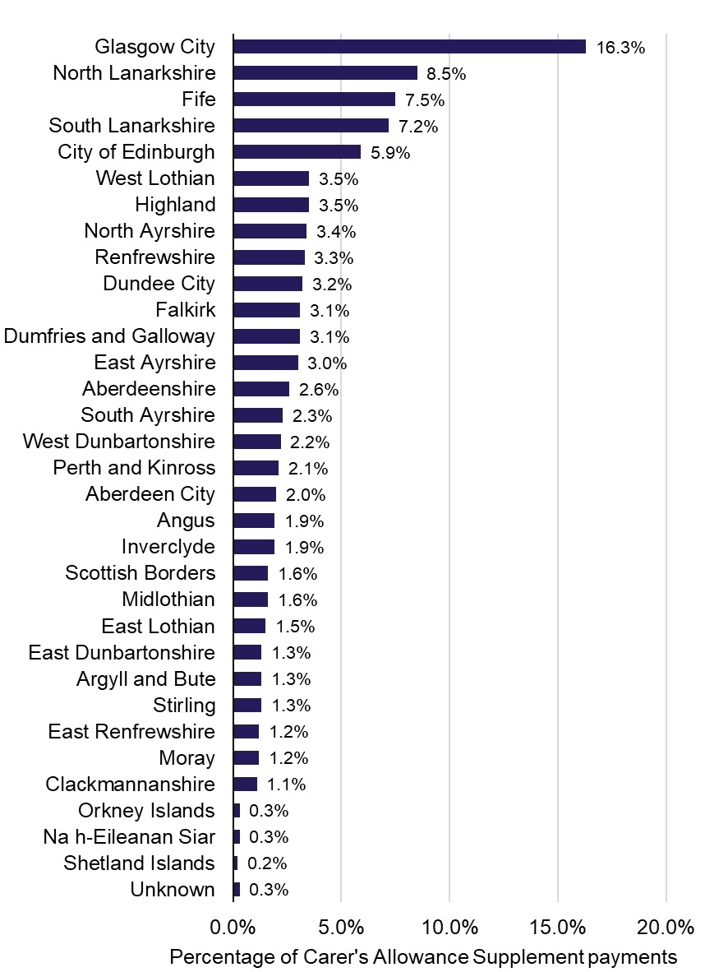

# Carer’s Allowance Supplement Payments since September 2018

* Since September 2018, 153,380 CAS payments have been made to 83,000 carers who were eligible in either or both of the eligibility dates in 2018 **[Table 2]**. Each payment was £221, giving a total expenditure of £33.9 m.
* The number of carers in receipt of CAS decreased from the April to October eligibility dates (1,860 fewer payments) **[Table 1]**. This difference may be due to backdating, so may change with future updates (See Background Note).
* The number of carers in receipt of CAS decreased between April and October eligibility dates for each age band except those aged between 60-64, which increased by about 500. This age band had the highest retention of carers on CAS from the April and October eligibility dates (98 per cent), plus newly eligible carers were identified **[Chart 3]**.
* The percentage of carers in receipt of CAS in each local authority was similar for both April and October eligibility dates (changed by less than 0.1 percentage points) **[Table 2]**.

**Chart 3: Number of carers in receipt of Carer’s Allowance Supplement payments by age band – 2018 eligibility dates**



# Background to Carer’s Allowance

Carer's Allowance was introduced on 5th July 1976. To be eligible for carer’s allowance:

- The person being cared formust already get one of these benefits:

Personal Independence Payment - daily living component

Disability Living Allowance - the middle or highest care rate

Attendance Allowance

Constant Attendance Allowance at or above the normal maximum rate with an Industrial Injuries Disablement Benefit

Constant Attendance Allowance at the basic (full day) rate with a War Disablement Pension

Armed Forces Independence Payment

- The carer must earn no more than £120 a week after tax and expenses. Expenses can include:

50 per cent of the carer’s pension contributions

some of the costs of caring for the carer’s children or the disabled person while you’re at work

- And the carer must also:

be 16 or over

spend at least 35 hours a week caring for someone

have been in England, Scotland or Wales for at least two of the last three years (this does not apply if you’re a refugee or have humanitarian protection status)

normally live in England, Scotland or Wales, or live abroad as a member of the armed forces

not be in full-time education

not be studying for 21 hours a week or more

not be subject to [immigration control](http://www.adviceguide.org.uk/england/benefits_e/benefits_coming_from_abroad_and_claiming_benefits_hrt/non-eea_nationals_and_the_hrt/are_you_subject_to_immigration_control_hrt.htm)

Some carers might still be eligible if they are moving to or already living in another [EEA country or Switzerland](https://www.gov.uk/claiming-benefits-move-travel-abroad/where-you-can-claim-benefits).

Some carers are entitled to receive Carer's Allowance because they satisfy the conditions listed above, but they do not actually receive a payment. This may occur as a temporary suspension of the Carer’s Allowance payments, if the claimant is in hospital. Otherwise, this is because the claimant receives another benefit (e.g. Incapacity Benefit for people of working age, or State Pension for people of State Pension age) which equals or exceeds their weekly rate of Carer's Allowance.

Where the overlapping benefit paid is less than the weekly rate of Carer’s Allowance, only the amount of Carer's Allowance which exceeds the amount of the overlapping benefit is paid. Carers who are on low income and entitled to Carer's Allowance (whether in payment or not) may receive extra money with their Income Support/Jobseeker's Allowance/ Pension Credit/Housing Benefit/Council Tax Benefit.

# Background to the Carer’s Allowance Supplement

The Scotland Act 2016[4] gives Scottish Parliament powers over a number of social security benefits which had been administered to Scottish claimants by the Department for Work and Pensions (DWP). In September 2018, Carer’s Allowance became the first of these benefits to have executive competency transferred from DWP to Social Security Scotland, the executive agency of Scottish Government which is responsible for delivering the social security benefits for Scotland. More information on Carer’s Allowance can be found above.

There is a transitional period to allow administration of this benefit to be transferred, during which DWP will continue to administer Carer’s Allowance on Social Security Scotland’s behalf. During this time, Scottish recipients of Carer’s Allowance will be eligible to receive CAS, which will raise their Carer’s Allowance to the equivalent of the current rate of Jobseeker’s Allowance for 25 and over.

CAS payments are paid twice a year. Payments for those eligible for CAS on the April 2018 eligibility date – 16 April – which were made in September 2018 and payments for the October 2018 eligibility date – 15 October – which were made from December 2018. These were the first payments made by Social Security Scotland.

In 2018/19 each payment was £221. This will rise to £226.20 for 2019/20.

To be eligible for CAS the person you care for does not have to live in Scotland, but you must:

* live in Scotland on the qualifying date;
* be getting Carer's Allowance payments on the qualifying date.

**About the data**

## How the data is collected

DWP holds information on those in payment of Carer’s Allowance, and it runs a scan of this data twice a year to identify those eligible for CAS on each of the eligibility dates. It then securely transfers the necessary data to Social Security Scotland to allow them to make CAS payments.

In some instances, payment of Carer’s Allowance can be backdated, which may mean that someone who did not receive Carer’s Allowance on the CAS eligibility date is later considered to have been eligible on that date. In order to capture these people, each scan of the DWP data will identify people who have retrospective entitlement to earlier eligibility dates, as well as identifying those in receipt of Carer’s Allowance on the most recent eligibility date. Social Security Scotland will then pay CAS for one or more periods of eligibility as determined by the data transfer.

The April 2018 eligibility date scan was run in August 2018, and the October 2018 eligibility date scan was run in November 2018.

## Data Quality

To take account of backdating, each eligibility scan identifies those people that have retrospective entitlement for previous CAS eligibility dates. The data in this publication includes those found to be eligible from the April 2018 eligibility date scan, as well as those identified in the October 2018 eligibility scan as having retrospective entitlement for April 2018. The October 2018 data will not include retrospective entitlement until the next eligibility scan (April 2019). Future scans may continue to identify additional people who are retrospectively entitled for any previous eligibility date. Because of this, there may be a small undercount for the April 2018 eligibility date and a larger undercount for the October eligibility date.

Gender data are based on ‘title’. Title was supplied for every carer. ‘Unknown’ gender includes carers with titles where gender cannot be identified, i.e. 'Dr', 'Rev' and 'Captain'.

Age is based on age at the eligibility date. In a very small number of cases age band is ‘unknown’.

A small number of carers (235 at the October eligibility date, which is less than one per cent) have ‘unknown’ local authority due to their supplied postcodes not matching the postcode address file used for statistical analysis.

Payments figures have been rounded to the nearest five, and expenditure figures to the nearest £1,000 for disclosure control.

## Comparisons between Carer’s Allowance and Carer’s Allowance Supplement Statistics

The eligibility for CAS is dependent on a person being in payment of Carer’s Allowance on the eligibility date. The data is therefore similar to the Carer’s Allowance statistics published here and by DWP[5]. However, there are a number of differences between these two sets of data. The key differences are:

* Reference date – CAS data refers to 16 April 2018 and 15 October 2018, while Carer’s Allowance data refers to the end of May 2018 and end of November 2018.
* Backdating – CAS data is taken from scans carried out in August and November 2018, and therefore the April eligibility data currently includes seven months of backdating and the October eligibility data includes one month of backdating. Carer’s Allowance data includes up to four months of backdating.
* Eligibility – all those who receive a payment of Carer’s Allowance on the eligibility date will receive CAS. This will include eligible carers who subsequently become entitled to a payment, including cases which may have temporarily been suspended from payment. Carer’s Allowance data will exclude those who are later found to be ineligible for Carer’s Allowance as part of their backdating adjustments.
* Geography – DWP use different postcode address files to identify those who receive Carer’s Allowance who are living in Scottish postcodes.

The Carer’s Allowance data is available in more detail on Stat-Xplore, where you can access data at lower geographies e.g. Local Authority, Census Output Area, Scottish and Westminster Parliamentary Constituencies:

<https://stat-xplore.dwp.gov.uk/webapi/jsf/login.xhtml>.

**An Official Statistics publication for Scotland**

Official and National Statistics are produced to high professional standards set out in the Code of Practice for Official Statistics. Both undergo regular quality assurance reviews to ensure that they meet customer needs and are produced free from any political interference.

**Correspondence and enquiries**

For enquiries about this publication please contact:

Pippa Stone

Social Security Statistics

Telephone: 0131 244 1490

e-mail: [SocialSecurityStats@gov.scot](mailto:SocialSecurityStats@gov.scot)

For general enquiries about Scottish Government statistics please contact:

Office of the Chief Statistician, Telephone: 0131 244 0442,

e-mail: [statistics.enquiries@scotland.gsi.gov.uk](mailto:statistics.enquiries@scotland.gsi.gov.uk)

**How to access background or source data**

The data collected for this statistical bulletin:

are available in more detail through [statistics.gov.scot](http://statistics.gov.scot/)

are available via an alternative route. Summary tables are available at:

[//www2.gov.scot/Topics/Statistics/Browse/Social-Welfare/SocialSecurityforScotland](https://www2.gov.scot/Topics/Statistics/Browse/Social-Welfare/SocialSecurityforScotland)

may be made available on request, subject to consideration of legal and ethical factors. Please contact [SocialSecurityStats@gov.scot](mailto:SocialSecurityStats@gov.scot) for further information.

cannot be made available by Scottish Government for further analysis as Scottish Government is not the data controller.

**Complaints and suggestions**

If you are not satisfied with our service or have any comments or suggestions, please write to the Chief Statistician, 3WR, St Andrews House, Edinburgh, EH1 3DG, Telephone: (0131) 244 0302, e-mail [statistics.enquiries@scotland.gsi.gov.uk](mailto:statistics.enquiries@scotland.gsi.gov.uk).

If you would like to be consulted about statistical collections or receive notification of publications, please register your interest at [www.gov.scot/scotstat](http://www.gov.scot/scotstat)

Details of forthcoming publications can be found at [www.gov.scot/statistics](http://www.gov.scot/statistics)

**Crown Copyright**

You may use or re-use this information (not including logos) free of charge in any format or medium, under the terms of the Open Government Licence. See: [www.nationalarchives.gov.uk/doc/open-government-licence/](http://www.nationalarchives.gov.uk/doc/open-government-licence/)

1. The Code of Practice is found online at: <http://www.statisticsauthority.gov.uk/assessment/code-of-practice/index.html>
2. The forthcoming publication timetable is available at: <http://www.gov.scot/Publications/2005/03/18798>
3. For more information on experimental statistics please see:

   <https://www.statisticsauthority.gov.uk/wp-content/uploads/2010/12/images-assessmentanddesignationofexperimentalstatistic_tcm97-44327-1.pdf>
4. The Scotland Act 2016 webpage at <http://services.parliament.uk/bills/2015-16/scotland.html>
5. Carer’s Allowance statistics are published as part of DWP’s benefits statistics collection:

   <https://www.gov.uk/government/collections/dwp-statistical-summaries>